<http://solarisfacts.blogspot.com/p/drilling-down-file-system.html#:~:text=UFS(Unix%20File%20System)%20is,or%20as%20primary%20file%20system>.

Solaris ZFS: <https://www.youtube.com/watch?v=n3kjqaVdZ-E>

ZFS is the root file system of Solaris 11

Echo | format = to display the hard disks installed

In order to use the zfs file system first create a pool of devices.

In solaris 11 zfs, with one command can create and mount the file system.

Zpool create mypool disk1 disk2

The devcices may consist of disks, large files etc. means, not only disk

Df –j or df –h = command to find the file systems currently mounted

Rpool is the default pool name // zpool list

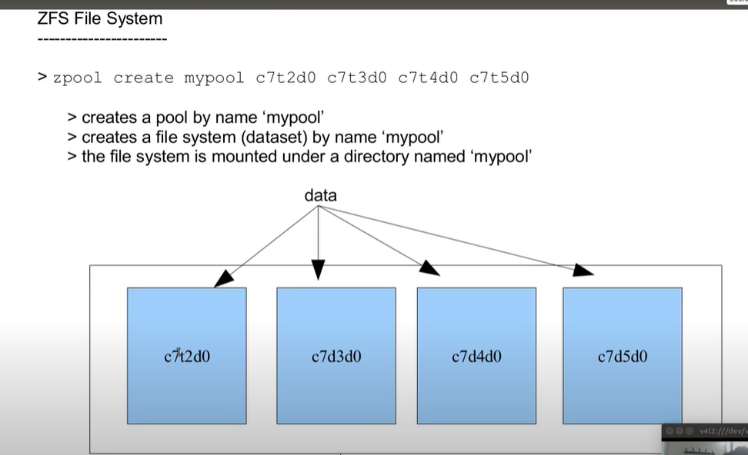

The data is striped across each disks, so a loss of 1 disk causes data loss. No redundancy.

Zfs create mypool/fs1

Zfs list = to list the file system.

Zfs is a property centric file-system. Manage it by setting and getting properties.

Zfs get all mypool

Zfs set mountpoint=/eng mypool/fs1 = to set the mountpoint for the mypool/fs1



Zpool add mypool disk3 = adding another disk to ‘mypool’

Zfs set quota=500m mypool/fs1 = setting quota on the filesystem/dataset of ‘fs1’

Setting a quota is not a guarantee, but it is only an upper limit.

Zfs set reservation=500m mypool/fs1 = is now a guarantee

Zpool status mypool = shows devices in the pool

Zpool destroy mypool

Mirror pool:



Data will be striped across virtual devices.

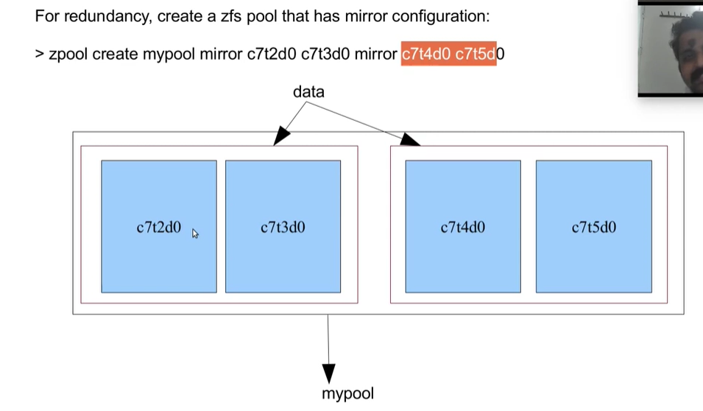

Create a pool with parity 1 disk:



Create large file: mkfile



Snapshot can be taken on zfs file system.

Du –sh <filename> = to find the file size



List the snapshot taken:



When the original files are removed from the file system, it is added to the snapshot. Not when it exists on the file system.

Restore/rollback the snapshot:



Snapshot is hidden under a hidden directory:



Showing a hidden directory in the zfs:

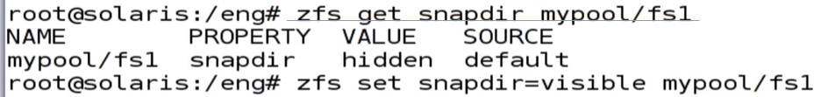

Share a file system: dfshares



No etc/dfstab entry required

A clone of a filesystem can be created only from its snapshot.



A clone is a writable copy.

Promoting a clone to a file system as original:

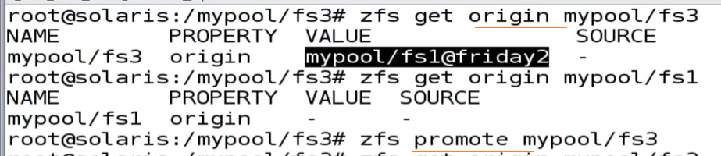

Sending a snapshot to an nfs share or some other place as a backup

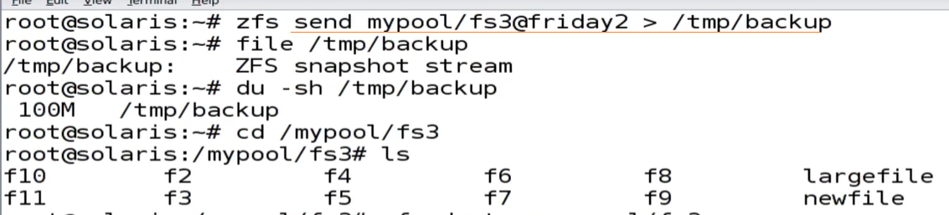

Restoring the file from backup:



Sending a snapshot from one machine to another using ssh:



A destroyed pool can be recovered:



Zone: <https://www.youtube.com/watch?v=eQ4z-65zdKw>

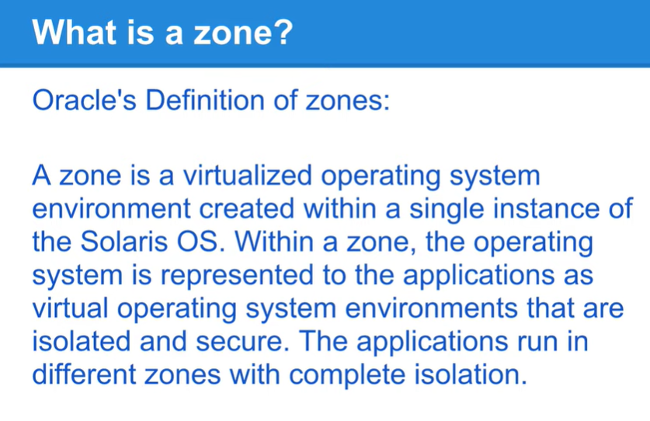

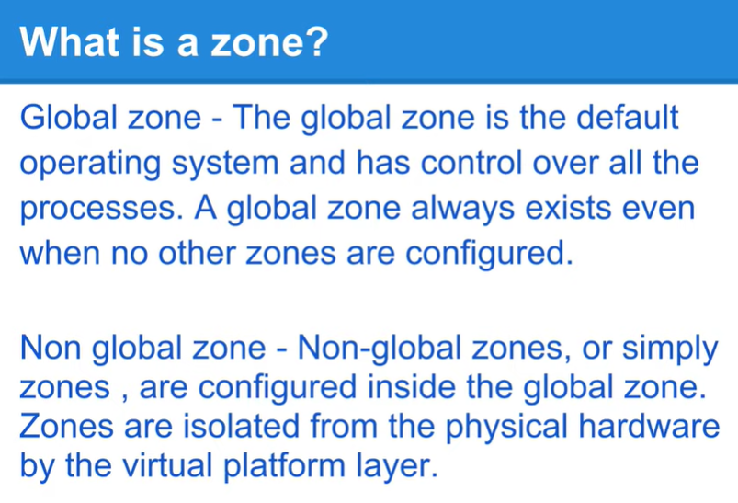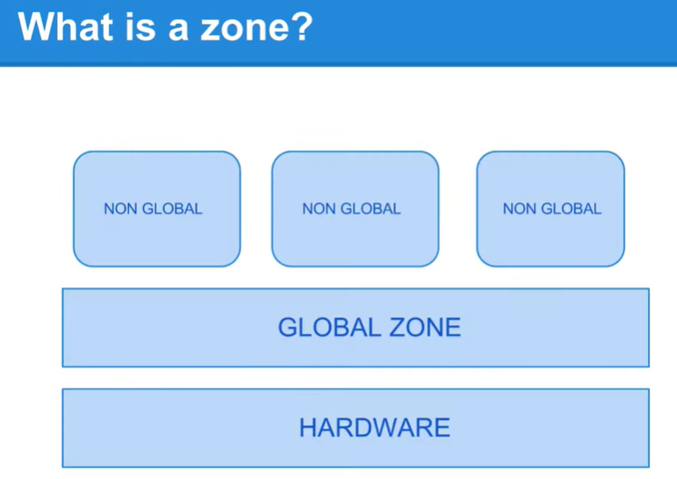

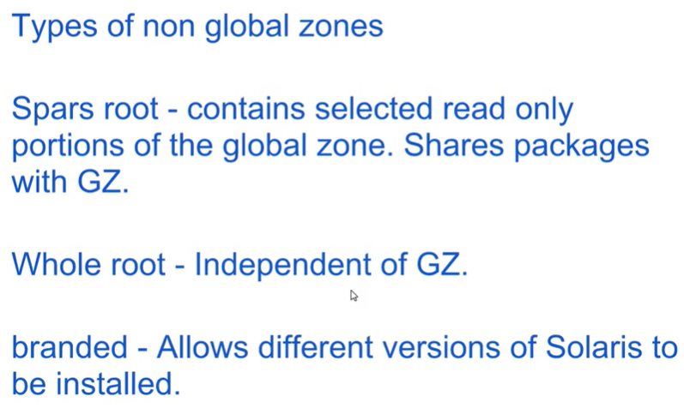

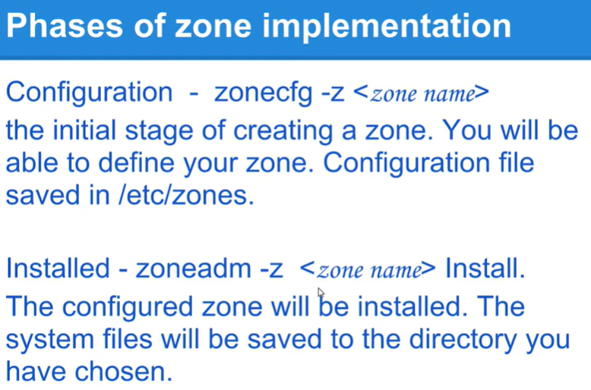

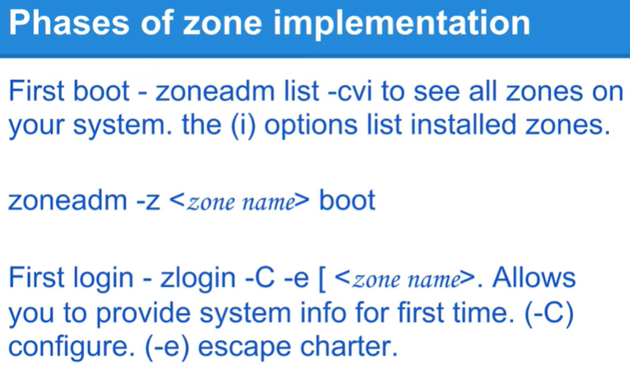

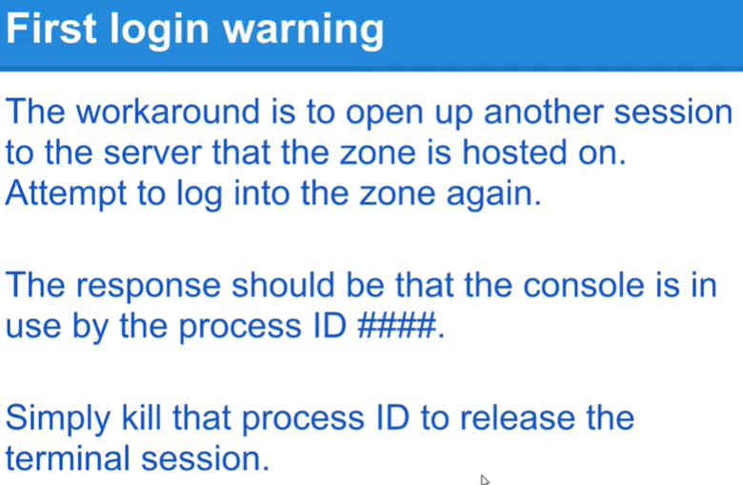

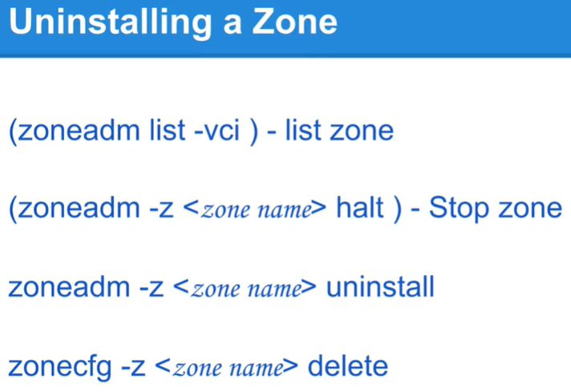

With Solaris zones introduced in Solaris 10, we can install multiple **instances** of the same OS installed. One base installation (one kernel) and many instances of it.

No additional layer of hypervisors.

Most of the applications that run on solaris 11 are certified to run on solaris 11 zone also.

Zoneadm list –cv = to see howmany zones are currently running

Global zone is the base zone.

Zonecfg = for zone confirguration

/etc/zones = when configuring a new zone, SYSdefault.xml template is used to set the path. Ip-type can be either ‘shared’ or ‘exclusive’

Ipadm showaddr = to show the ip address

In solaris 11 any number of ‘vnic’s can be created (virtual nic) for virtualization.

Zfs is the root file system, that is the zonepath

Create a zfs filesystm and mount:

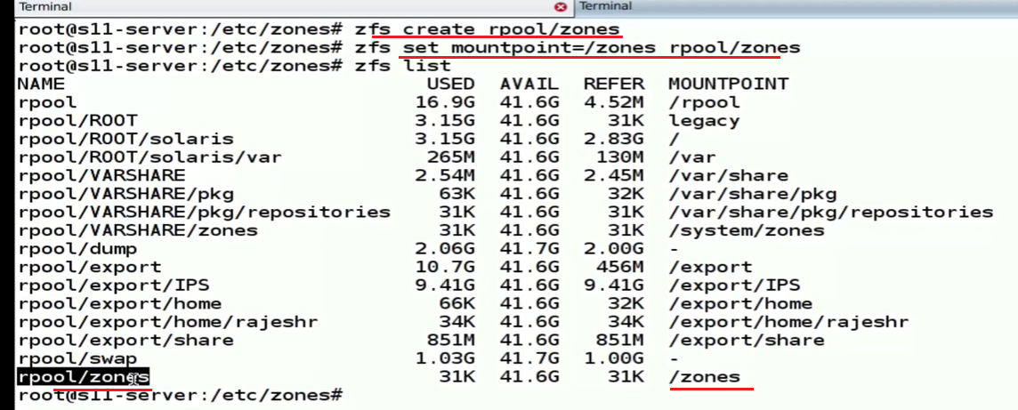

Configure a zone and set zonepath to the zfs file system and add network port:

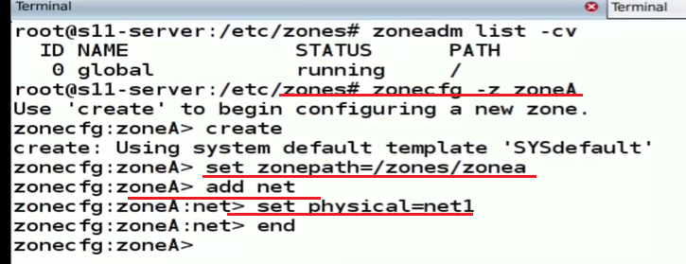

If high availability is needed on a zone, add 2 ports to the zone. No need to assign a physical port, can assign a vnic built on top of the physical device.

A zone is a virtual instance of an OS

Add a resource in the zone and set value for its attribute.

Verify the configuration and exit

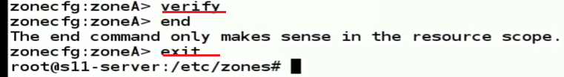

After creating a zone, a file is created inside the /etc/zones folder as <zonename>.xml with all the configurations for that zone.

Removing a resource from the zone:

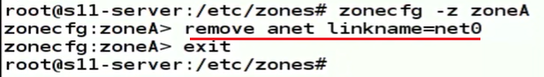

Anet is automatic net

Ips = image packaging system in solaris 11. To install solaris, need access to the repository

Install the zone:

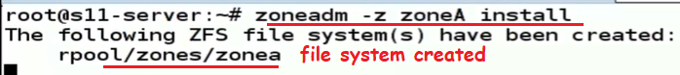

Zone creation status: configured, incomplete, installed, ready, running

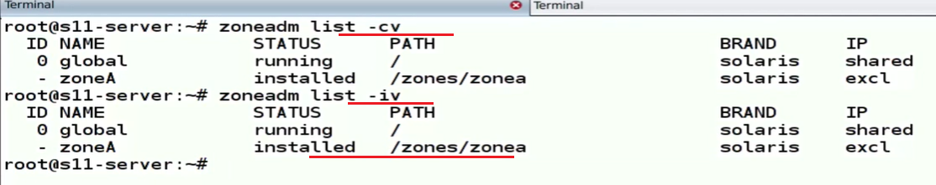

Zoneadm –z ZoneA boot = to boot the zone

A zone is known by its name, not by id

Deamon zoneadmd is responsible for booting the zone, assign an ip address, assign an id.



Zonename = to find the zone name

Svcs ssh

Zoneadm –z ZoneA shutdown = for shutting down

Zlogin –C <Zonename> = to access the zone console.

#pkg info entire

#pkg publisher solaris

#dladm = create virtual network create-vnic

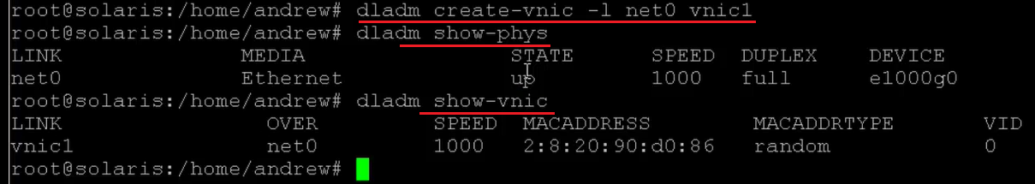

Create the zone:

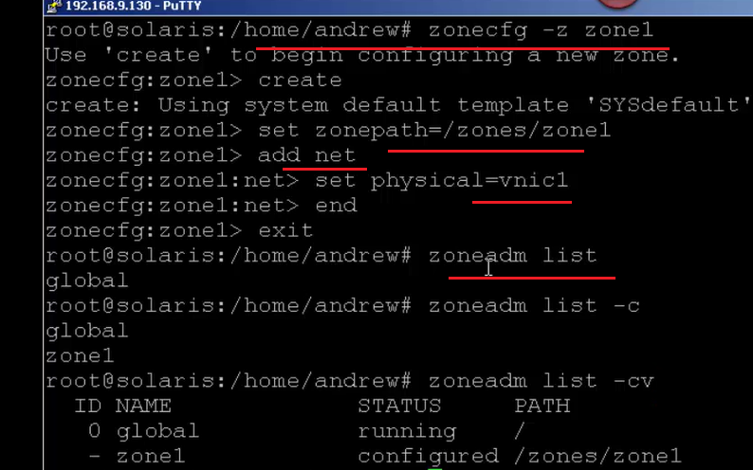

Sysconfig: this is the answer file for the installation



Installing:



#pkg install <packagename>

#svcadm enable <servicename>

#zonestate 5 = retrieving the zone status after 5 seconds

#zonecfg –z zoneA info = to get more info about the zone

#zonename

Adding a resource from the global zone:

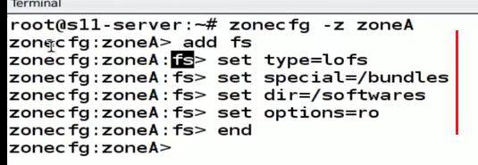

Only the global id will be stable, which is 0

#echo | format = to show the disks we have

#newfs = to create a ufs file system

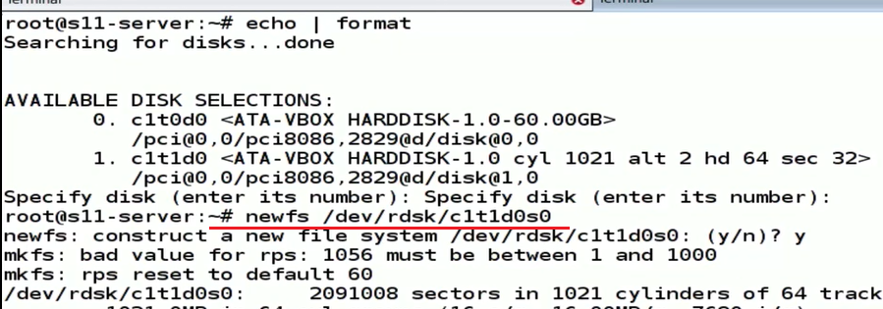

Adding a ufs resource into the zone:

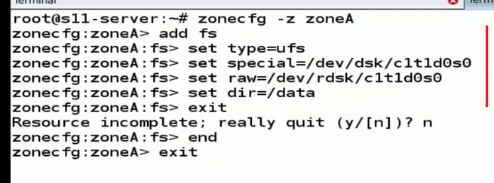

Mount the filesystem in the non-global zone from the global zone:



Added a zfs file system resource:

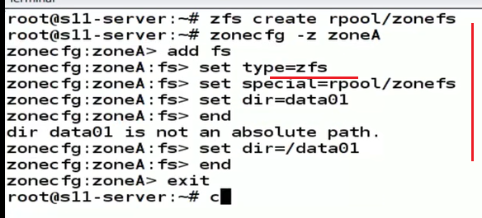

Adding a dataset:

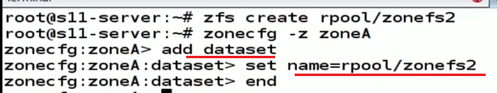

Zoned:

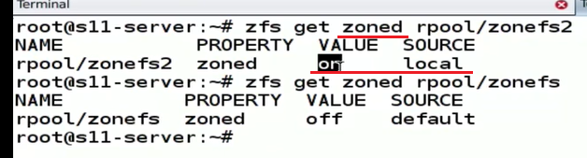

Prtconf: checking memory

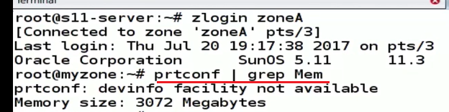

**grep**, **egrep**, **fgrep**, **rgrep**, **pgrep** - are commands in Unix-like operating systems that print lines matching a pattern. The grep searches the named input FILEs for lines containing a match to the given PATTERN. By default, it prints the matching lines. In addition, the variant programs **egrep**, **fgrep**, and rgrep are the same as **grep -E**, **grep -F**, and **grep -r**, respectively.

|  |  |
| --- | --- |
| ^ | the circumflex is used to match the beginning of a line. |
| $ | used to match the end of a line. |
| . | matches any character except a new line. |
| [] | matches single character inside the brackets. If there's a ^ inside, it would match anything but the characters in the bracket. |
| \ | before any of the non-alphanumeric characters quotes them. |
| * | symbol matches the preceding character or subexpression zero, one or more times. |
| \1 | backreferences 1-9 match the exact text by the corresponding group. |
| \{m,n\} | matches the preceding elements at least *m* and no more than *n* times. |
| \| | foo\|bar matches foo or bar. |
| \? | short for {0,1} |
| \+ | (short for **{1,}**) match the preceding character or subexpression at most 1 time, or at least 1 time respectively. |
| \n | matches a newline, \t matches a tab, etc. |
| \w | matches any word constituent and \W matches any character that isn't a word constituent. |
| \<\> | match the empty string only at the beginning or end of a word |
| \b | matches either and **\B** matches where \b doesn't. |
| **Symbol** | **Details Extended Regular Expressions (ERE)** |
| ^ | match only at the beginning |
| $ | match only at the end of a line. |
| . | matches any character (or any character except a newline). |
| […] | matches any one character listed inside the brackets (character set). Add an initial ^ and ranges work like in BRE (see above). |
| (…) | syntactic group, for use with * or \DIGIT replacements. |
| \| | for alternation: foo|bar matches foo or bar. |
| * | matches the preceding character or subexpression a number of times: 0, 1 or more times |
| + | matches 1 or more times preceding character. |
| ? | matches preceding characters 0 or 1 times. |
| \ | Backslash quotes the next character if it is not alphanumeric. |
| {m,n} | matches the preceding character or subexpression between m and n times (missing from some i |

Capped memory:

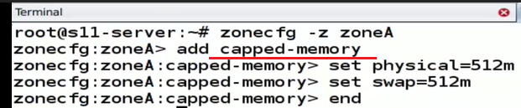

Enable rcap: rcapadm –E



Pooladm, poolcfg poold daemon

Adding cpu:

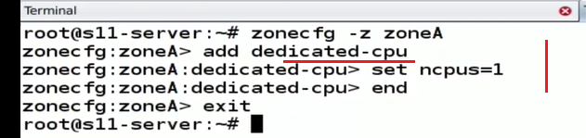

Man zonecfg

A ‘stub’ is a private switch in solaris 11

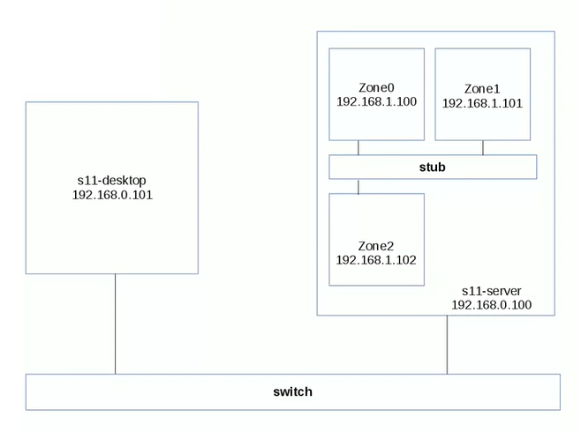

Dladm show-etherstub = to show the stub

Dladm create-etherstub

Export a zone configuration:



Create a zone from an existing configuragation



Create a vnic:

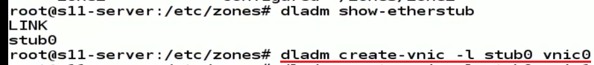

Router is a device that knows multiple networks

@dladm show-link = will show the ports

Create an ip address:

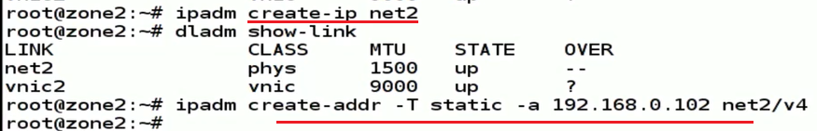

Ip forwarding:

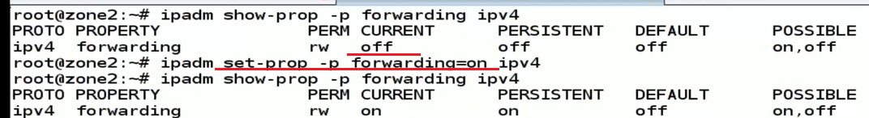

Traceroute <ip addr> = to check the network route

Dladm delete-vnic vnic0

For automated installation of solaris, we need 3 servers plus client. 1)AI for automated client interaction 2) DHCP for providing ip address to client, 3) Image packaging repository

LDOM (Logical Domain) – VM Server

CMT is chip multi threading

Niagara processor and UltraSparc Hypervisor

Th e Ul tr aS PARChy perv isor is a thi n layerof sof tw are stored withintheAL OMCMTfirm ware.

Hy perpriv ileg ed accessenablesthe hyper -vis or to eith er exp oseor hi de res ourcesfroman ins tanceof an op er atingsys -tem.Th is al low s res ourcesto be grouped intologicalpa rtitions or domains.

Re source s su ch as CPU threads, cryp tographic threads, an d memory are par -titioned intoa lo gi cal domain . Otherres ourcesare virtualiz ed and servicedthr oughthe useof Logica l Domain Channels, or LDCs.LDCsprovide securecommunicationandda ta pa thways between LDomsand th e hypervisor.Th is al low s an operati ng systemin oneLDomto make an I/Orequest, whichis servic ed by an other LDomthatha s privilegedacc ess to the underlyinghard ware

Log ic al DomainTypeDescri ption

1. Gue stDomain th at is a consumerof virtualize d devicesandserv ic es
2. I/ODomain th at hasprivi legedaccess to a PCI-Econtrollerbutdo es notprovide vi rtualizeddevi ces or se rvicesto guestdo mai ns
3. Serv ic eI/O domain thathasprivilegedaccess to oneor morePC I- Econtroll er s; provides vi rtu al iz ed devi ce s andservicesto guestdo mai ns
4. ControlService domain th at runs managementsoftwareto controlthehyp ervisor con figurati on of th e pl atform

Psrinfo –v | more for the processors info

Solaris LDoms is a server virtualization and partitioning technology that is used by many enterprises to host multiple instances of Solaris or Linux virtual machines (VMs) on a Sun server. The LDoms (or Logical Domains) technology allows administrators to allocate a system's various resources, such as memory, CPUs, and devices, into logical groupings and create multiple, discrete systems, each with their own operating system, resources, and identity within a single computer system.

A Solaris LDoms server has multiple guest domains and a single control domain for monitoring and reconfiguration of the guest domains. The guest domains are where the applications are hosted, and can be independently powered on and off without affecting other domains. The applications on the logical domains use the virtual CPU/disk/memory resources that the hypervisor allocates to every guest.

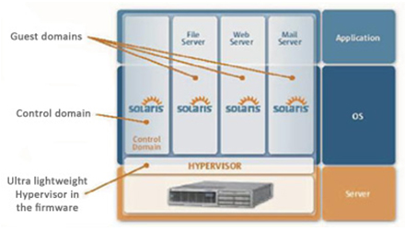The architecture of a Solaris LDoms server

# [Difference between LDOM and Zones](http://solsupport.blogspot.com/2010/10/difference-between-ldom-and-zones.html)

Sun Logical Domains or LDoms is a full virtual machine that  
runs an independent operating system instance and contains  
virtualized CPU, memory, storage, console, and cryptographic  
devices.  
This technology allows you to allocate a system resources  
into logical groupings and create multiple, discrete  
systems, each with their own operating system, resources,  
and identity within a single computer system.  
We can run a variety of applications software in different  
logical domains and keep them independent of performance and  
security purposes.  
  
A zone is a virtual operating system abstraction that  
provides a protected environment in which applications run.  
The applications are protected from each other to provide  
software fault isolation. To ease the labor of managing  
multiple applications and their environments, they co-exist  
within one operating system instance, and are usually  
managed as one entity.  
  
LDOMs allow you to assign your hardware to different virtual hosts for exclusive use. Say you have a T5220 with an 8-core CPU. You could create 8 LDOMs and assign a core to each. Each core will be for the exclusive use of the domain you assigned it to, regardless of the load on the other domains. With zones/containers, all zones can use any CPU core/thread that they need when they need it. Limits can be set as far as how much CPU they use, but you cannot specify which CPU/core/thread they are to use.  
  
With LDOMs you get an OBP per domain that can be configured independently from the others. Zones don't have OBPs.  
  
You can "brand" a zone as a Solaris 8 or Solaris 9 zone (and I understand RHEL as well), running an instance of either OS on top of Solaris 10. This is useful in those cases when you are refreshing hardware but app vendors only support their apps on the older OSs. You can't "brand" an LDOM, but you can create a branded zone inside an LDOM.  
  
Root on the global zone can see all of the file systems on each zone.  
Root on the primary domain cannot see the files systems on the domains.  
  
Solaris Containers  
------------------  
No special hardware required  
Single OS image  
Sub-CPU resource granularity  
Shared kernel, memory, file systems (configuration, resources and  
management)  
Solaris only (excluding Linux branded zone on x86)  
CPUs can be shared  
Works on all systems  
Virtually unlimited partitioning (max is 8191 non-global zones)  
Single system patch level  
Most admin operations can be applied to all containers in a single operation  
Very little performance overhead for zone infrastructure  
  
  
LDoms  
-----  
Sun4v systems only  
Multiple OS images  
Multiples of CPU granularity  
Dedicated kernel, memory, file systems  
Can support other OSes  
CPUs can not be shared (CPUs here refers to a strand/thread)  
Currently available on Tx000, T5xy0 only  
Partitioning limited to number of CPUs  
Multiple and different patch and release levels possible  
Each LDom must be fully managed separately

LDOM is a hardware virtualization which works on top of the hypervisor.

* Control Domain is the place where you are going to install the LDOM software and managing the complete logical domain environment. It used to configure the resources and guest domains

* Service domain provides the various virtual services to guest domains. Virtaul services can be virtual disks,network switches or virtual consoles. Mostly we will be configuring the control domain as service domain too.

<https://www.unixarena.com/2014/02/ldom-oracle-vm-sparc-tutorial-1.html/>

Man page sections:

The standard sections of the manual include:

1 User Commands

2 System Calls

3 C Library Functions

4 Devices and Special Files

5 File Formats and Conventions

6 Games et. al.

7 Miscellanea

8 System Administration tools and Daemons

Package administration:

From Solaris 11, IPS is tightly coupled with ZFS.

<http://pkg.oracle.com/>

‘Pkg’ is the main command to work with Solaris packages

SRU – support repository updates

FMRI – fault managed resource identifier

Pkg kernel info // pkg publisher

Pkg info –r apptrace = fetch package info remotely (-r) // pkg search “apptrace”

Pkg install –n apptrace = this will do a dry run, no actual install // pkg install apptrace

Pkg uninstall apptrace

Beadm = boot environment file system // beadm create solaris-1

Beadm activate solaris-1 // change the be

Mounting a BE onto a mountpoint : 

Installing on the mounted BE:



SMF – service management facility

Svcs –a = will show all the services

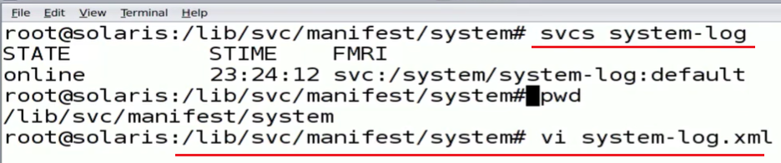

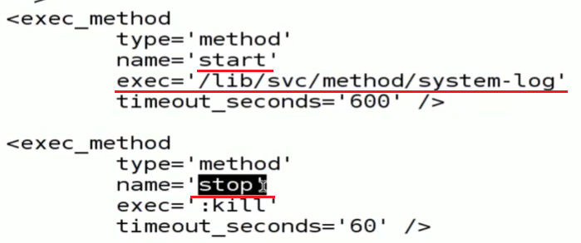

Every service has a manifest in xml.

/etc/svc has a depository.db it has all the service definitions. System uses this depository to start the services during the boot process.

Svccfg = Can interact with the depository using the

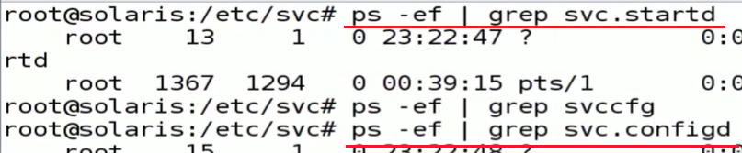

Svc.configd = interacts with the depository

Svc.startd = starts the services

Boot –m milestone = none –in a sparc machine when all services are down and want to switch to the repository.

Restore_repository

LDOM: <https://docs.oracle.com/cd/E35434_01/pdf/E23807.pdf>

*starend